**1st Year CIT**

**1-Electron theory** states **all matter is comprised of molecules, which in turn are comprised of atoms, which are again comprised of protons, neutrons and electrons**. A molecule is the smallest part of matter which can exist by itself and contains one or more atoms.

**Joseph John Thomson** (J. J. Thomson, 1856-1940; see photo at American Institute of Physics) is widely recognized as **the discoverer of the electron.**

## What is Atomic Structure?

The atomic structure of an element refers to the constitution of its nucleus and the arrangement of the electrons around it. Primarily, the atomic structure of matter is made up of [protons](https://byjus.com/chemistry/protons/), electrons and neutrons.

The **protons and neutrons** make up the nucleus of the atom, which is surrounded by the electrons belonging to the atom. The**atomic number** of an element describes the total number of protons in its nucleus.

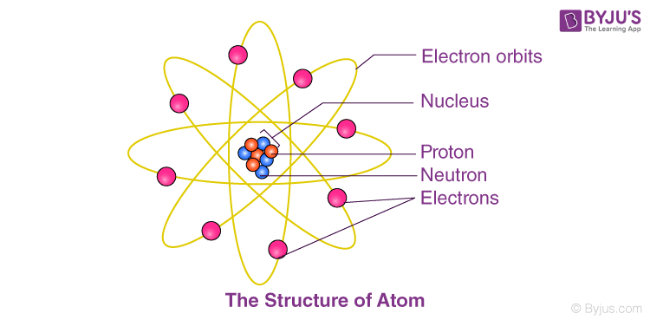

Neutral atoms have equal numbers of protons and electrons. However, atoms may gain or lose electrons in order to increase their stability and the resulting charged entity is called an ion.

Atoms of different elements have different atomic structures because they contain different numbers of [protons and electrons](https://byjus.com/chemistry/electrons/). This is the reason for the unique characteristics of different elements.

**K, L ,M SHELL**.

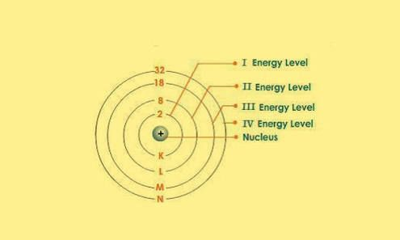

**ENERGY LEVEL.**

energy level, also called energy state, in physics, **any discrete value from a set of values of total energy for a subatomic particle confined by a force to a limited space or for a system of such particles, such as an atom or a nucleus**

**VALENCE ELECTRON.**

he electrons in the outermost shell are the **valence electrons--**the electrons on an atom that can be gained or lost in a chemical reaction. Since filled *d* or *f* subshells are seldom disturbed in a chemical reaction, we can define valence electrons as follows: **The electrons on an atom that are not present in the previous rare gas, ignoring filled d or f subshells.**

**ENERGY BANDS.**

**Definition**: According to Bohr’s theory, each and every shell and subshell of atoms contain a discrete amount of energy. An atom has different energy levels. When atoms are brought closer to each other, electrons at outermost shell interact with each other. This bonding force between electrons is called as an inter-atomic interaction.

This interaction causes the change in energy levels of electrons at the outermost shell. This change will give rise to energy band theory, and hence electrons will not be at the same level, the levels of the electrons are changed to a value which is higher or lower than that of the original level.

Each substance consists different amount of electron energy present in the energy bands, based on these different energy levels. Energy band are then further classified as:

* Valence band
* Forbidden Energy Gap
* Conduction Band

These Band can be explained as

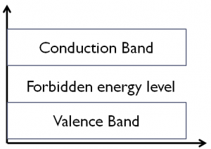

**Valence Band:**

At absolute zero temperature, there are the different range of energies present in the solid and the band which is formed by the highest range of energy is called valence band this band is filled with valence electrons.

Valence band can also be explained as, When atoms are brought closer together to form a solid, the discrete energy levels are disturbed because of quantum mechanical effects, and many electrons in the group of the individual atom occupy a band of levels in the solid, this band of levels called as valence band. This band is formed by the electrons at an outermost shell.

It is located below the Fermi level. Electrons in the valence band have lower energy than the electrons in the conduction band. In atoms, the electrons present in the valence band is loosely bound to the nucleus. The electrical conductivity of a solid depends on the capability to move the electrons from the valence band to the conduction band

## Forbidden Energy Level:

Forbidden energy gap is also known as Fermi energy level. It is the electronic energy band where there is no electron state exists due to quantization energy. The band obtained by separating conduction band and valence band is called as forbidden energy band or forbidden gap.

In solids, the electrons do not stay in forbidden gap as there is no energy state in this region. With the help of forbidden gap, we can determine the major factor, i.e., the electrical conductivity of the solid.

## Conduction Band

The energy band formed by the energy levels of the free electrons is called conduction band. The conduction band is an empty band or partially filled band, but when the external field is applied to the electrons in the valence band, the electrons jump from the valence band to the conduction band and becomes free electron.

Electrons in the conduction band have higher energy than the electrons in the valence band. In the conduction band electrons are not bound to the nucleus of the atom.

Conduction band can also be defined as empty states which are broadened into a band of levels. This band is placed above the Fermi level. It is the lowest range of vacant electronic state.

## Insulators

Stated simply, insulators are those materials in which valence electrons are bound very tightly to their parent atoms, thus requiring a very large electric field to remove them from the attraction of their nuclei.

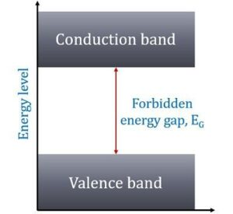Energy band level diagram of insulator

In other words, insulators have no free charge carriers available with them under normal conditions.

In terms of energy bands, it means that insulators [Fig(a)] have a full valence band,

1. have an empty conduction band,
2. have a large energy gap (of several eV) between them and
3. at ordinary temperatures, the probability of electrons from full valence band gaining sufficient energy so as to surmount energy gap and thus become available for conduction in the conduction band, is slight.

This is shown in Fig(a). For conduction to take place, electrons must be given sufficient energy to jump from the valence band to the conduction band.

Increase in temperature enables some electrons to go to the conduction band which fact accounts for the negative resistance temperature coefficient of insulators.

## Conductors

Put in a simple way, conducting materials are those in which plenty of free electrons are available for electric conduction.

In terms of energy bands, it means that electrical conductors are those which have overlapping valence and conduction bands as shown in Fig .

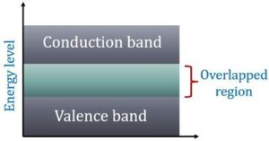

Energy band level diagram of conductor

In fact, there is no physical distinction between the two bands. Hence, the availability of a large number of conduction electrons.

Another point worth noting is that in the absence of forbidden energy gap in good conductors, there is no structure to establish holes.

The total current in such conductors is simply allowed of electrons. It is exactly for this reason that the existence of holes was not discovered until semiconductors were studied thoroughly.

## Semiconductors

A semiconductor material is one whose electrical properties lie in between those of insulators and good conductors. Examples are germanium and silicon.

In terms of energy bands, semiconductors can be defined as those materials which have almost an empty conduction band and almost filled valence band with a very narrow energy gap (of the order of 1 eV) separating the two.

